Java Package

A java package(Directories) is a group of similar types of classes, interfaces and sub-packages.

Package in java can be categorized in two form, built-in package and user-defined package.

There are many built-in packages such as java, lang, awt, javax, swing, net, io, util, sql etc.

Here, we will have the detailed learning of creating and using user-defined packages.

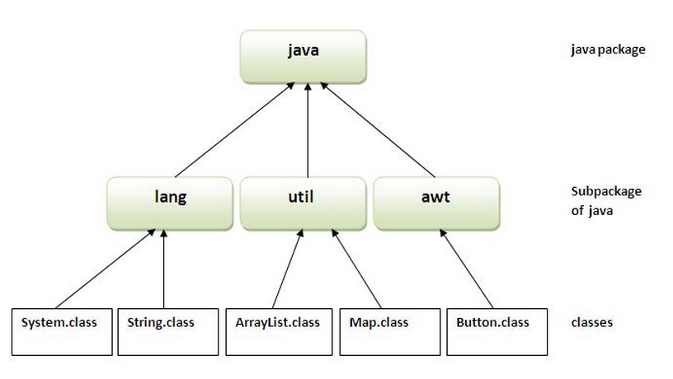

**other packages are---**

>Lang

-----system class

-----Object class

-----Class class

-----Reflect(Package)

---------Method class

---------Constructor class

---------Field class

>io

-----input stream class

-----output stream class

-----print stream class

>rmi

>sql(class realted to a data base)

>awt class

-----component class

-----container class

-----button class

-----text Field class

**Example:**

package p1;

class c1{

public void m1(){

System.out.println("m1 of class c1");

}

public static void main(String args[]){

c1 obj=new c1();

obj.m1();

}}

**Save it with demo.java**

in d:java folder

now go and compile it

in command prompt

D:\Java\javac demo.java

compile successfully.

Now make a package-------------

D:\Java\javac -d . demo.java

a package will be created in java folder with name p1 that have class c1

to create folder in parent directory use 2 dots.------------

D:\Java\javac -d .. demo.java

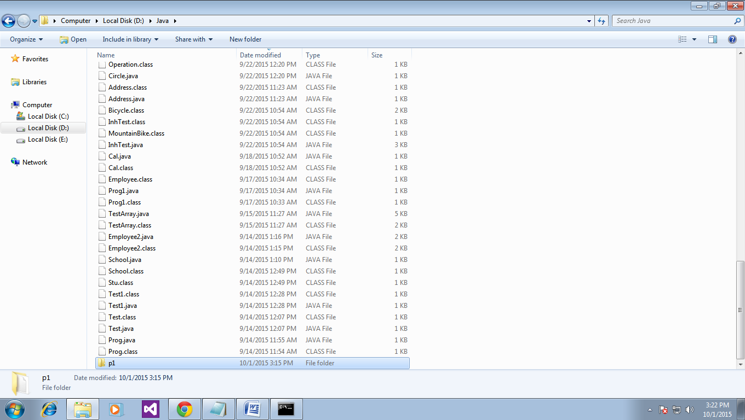

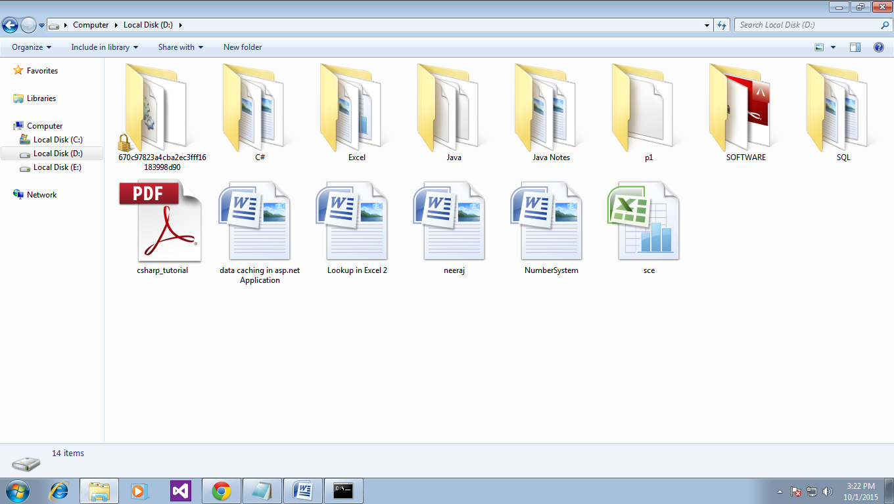

Now to make the sub package-----

**package p1.p2;**

class c1{

public void m1(){

System.out.println("m1 of class c1");

}

public static void main(String args[]){

c1 obj=new c1();

obj.m1();

} }

save it with name demo.java

compling---------

D:\Java\javac -d . demo.java

and see in p1 folder p2 is created with class c1 in it.

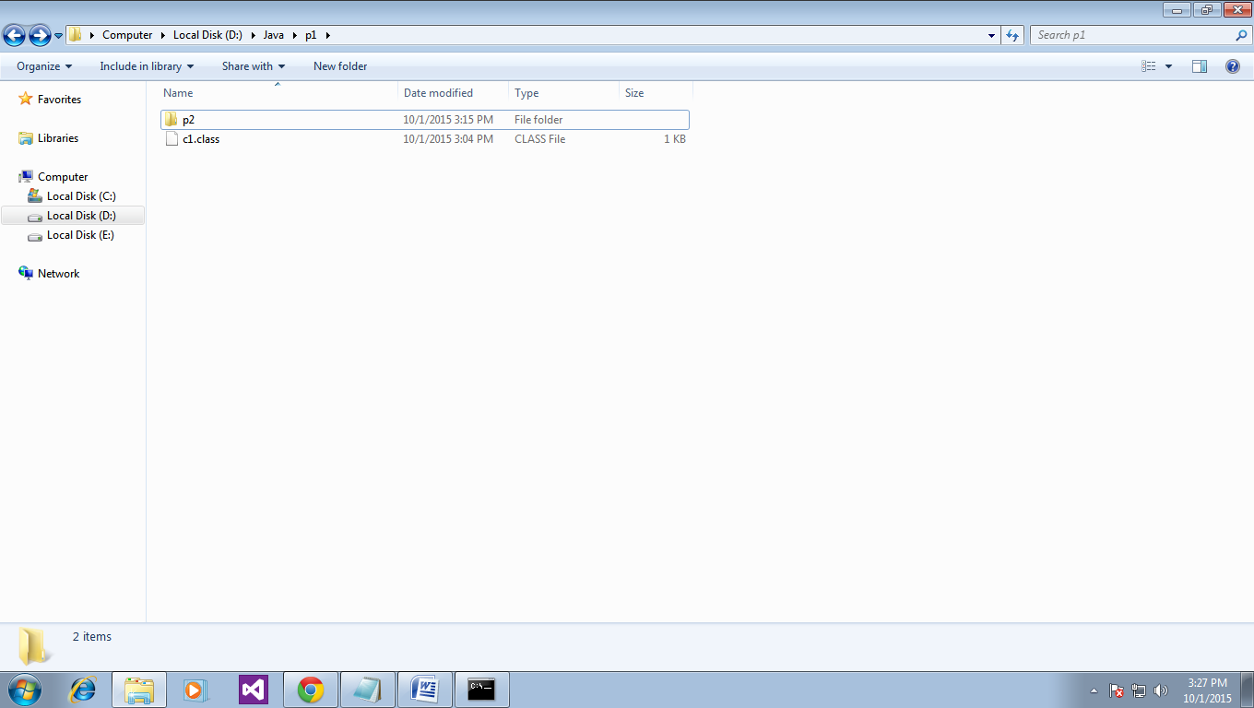

To execute the code write:

D:\Java\java p1.p2.c1 [In case of sub package]

D:\Java\java p1. c1 [In case of main package]

===========================

**Live example....**

package s1;

public class C1

{

public void fn1(){

System.out.println("Function of c1 class of package");

}}

save in d:\java\ with name C1.java

now make package as

D:\Java\javac -d . C1.java

check there in d--in java folder we get a folder with name s1

now import this s1 package in another application

**********

import s1.*;

class C2{

public static void main(String args[])

{

System.out.println("Main class");

C1 cobj=new C1();

cobj.fn1();

}}

save with name C2.java in d:\java\ folder

now compile with javac C2.java

if get error because of source file of C1 in current directory(C1.java), remove that file, now do compile again

successful

run it

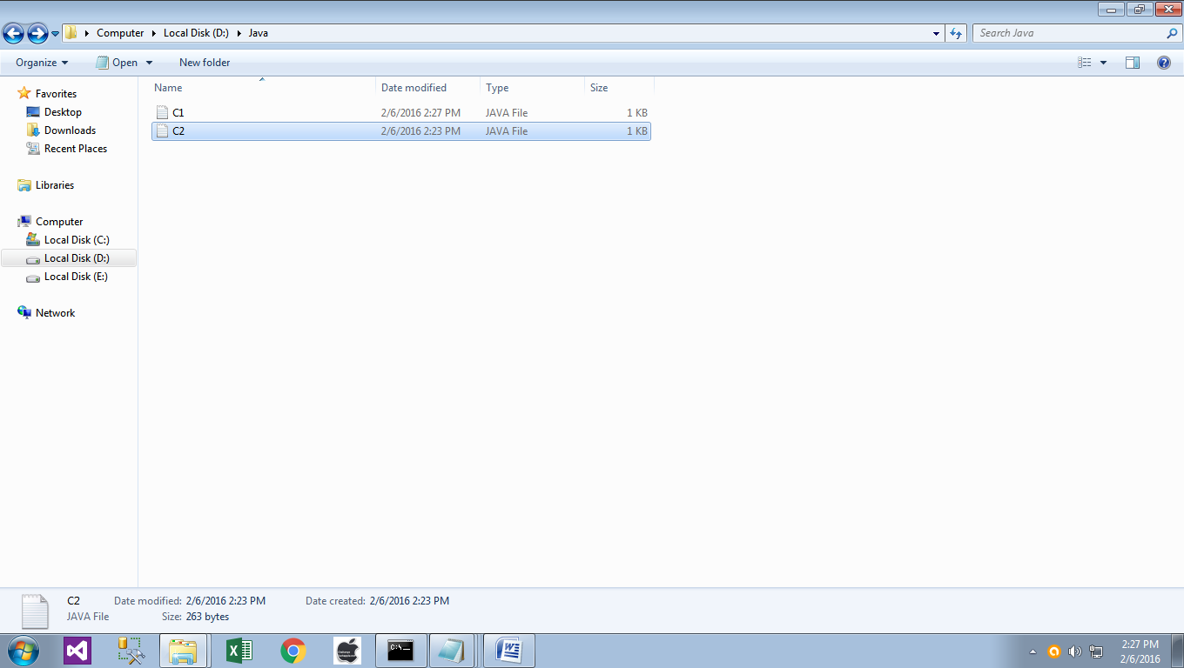

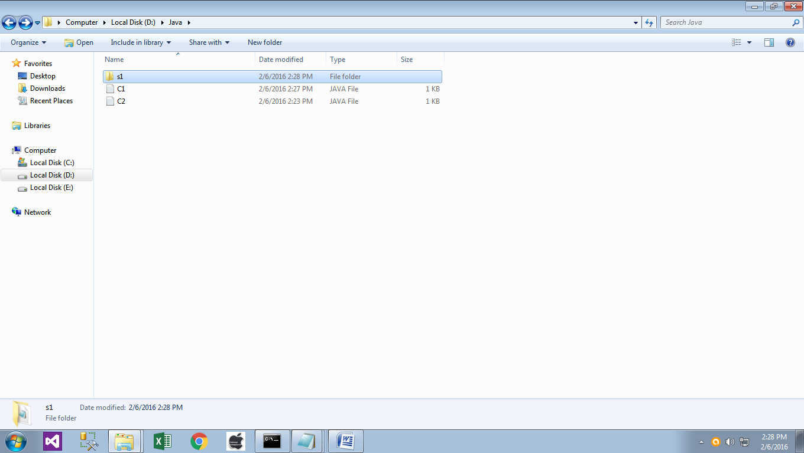

Now Delete C1.java file, from java folder.

S1 has C1.class file.

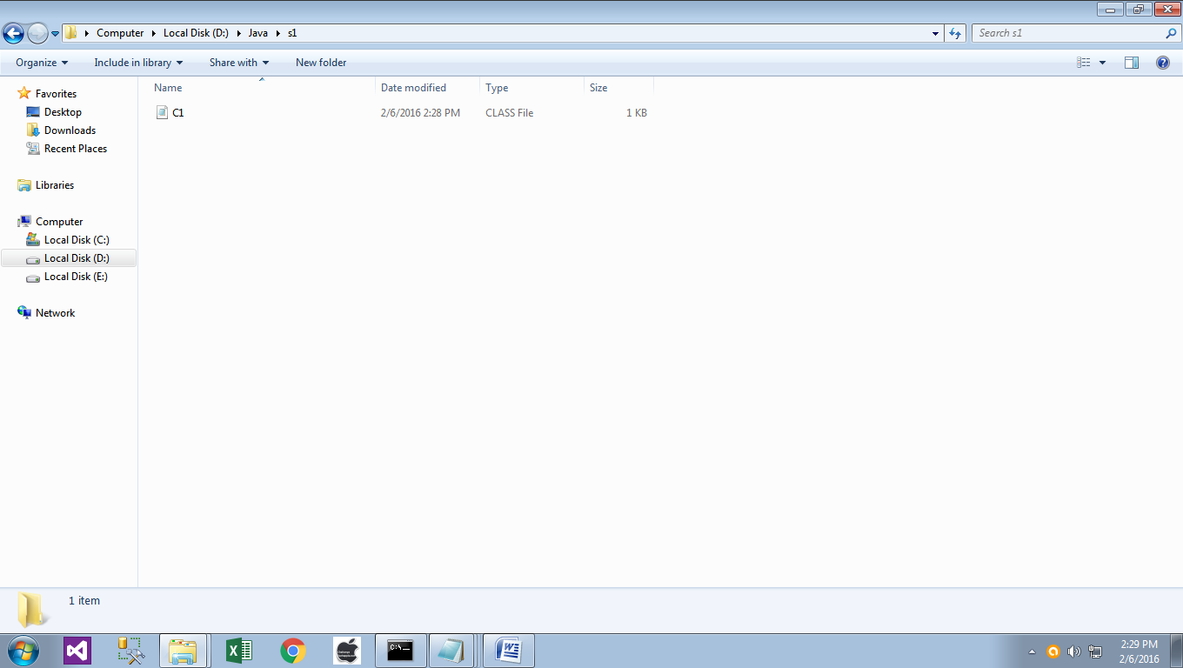

Now compile C2.java.

run it

D:\Java>javac -d . C1.java //will make folder with package name, and also create class file in folder.

D:\Java>javac C2.java

D:\Java>java C2

Main class

Function of c1 class of package

D:\Java>

how to access classes of a package to another location

like my package is in d drive

and i have to aces it in e drive.

we have to set class path at command prompt

like

one file is:

package comp1;

public class Computer {

public Computer(){

System.out.println("Computer class Constructor");

}

public void computer_method() {

System.out.println("Power gone! Shut down your PC soon...");

} }

save it with name Computer.java in d:java

second file is:

package comp1;

public class Laptop {

public Laptop(){

System.out.println("Laptop class Constructor");

}

public void laptop_method() {

System.out.println("99% Battery available.");

}}

save it with name Laptop.java in d:java

now command prompt

D:\Java\javac -d . Computer.java

D:\Java\javac -d . Laptop.java

you will get a folder with name Comp1 that have two class files with name Computer.class, Laptop.class in

D:\java\Comp1 folder

now create a java file with name Elec.java on desktop

import comp1.*;

class Elec{

public static void main(String[] args) {

Computer my = new Computer();

Laptop your = new Laptop();

my.computer_method();

your.laptop_method();

} }

goto command prompt

set desktop path

C:\Users\Administrator\Desktop>

set classpath=%CLASSPATH%;D:\jAVA;

it will set path of all classes of your package

now compile your Elec file run it you will get result.